Wadalba Community School
Progress with Pride
________________________________________________
Creating a quality learning community through opportunity, innovation and participation

Power4Learning Principal’s Award - Secondary

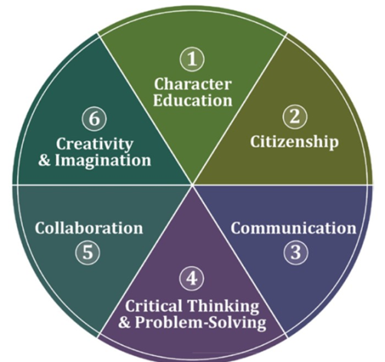
The Power4Learning Award recognises high quality 21st century learning.

The award recognises that in the 21st century quality learning:
- Occurs within classrooms school but is also supported by connected experiences “outside of the school fence” including within the local community, across the state/ country and as part of global citizenship
- Is student driven with high quality support from teachers and other expertise
- Promotes the 6Cs including character education; citizenship; communication; critical thinking and problem-solving; collaboration; and creativity and imagination.
Criteria:

- Students must demonstrate learning attributes in their classrooms but achieving a majority of “Always” on the current school report for the School Values- Commitment to Learning and Social Development”. That is, the tick boxes on each report page

- Students must demonstrate how they have improved their learning through a significant activity connected to their school learning (a) within the locally community (b) across the state/ country AND (c) as part of engaging as global citizen/ learner.
For each of the three areas in criteria two, students should describe the learning experience and its significance to their learning at school, including links to relevant aspects of the 6Cs. Approximate length is between 1-3 pages for each area or equivalent if using another presentation format such as video or powerpoint. Students are encouraged to use photos or other mediums in their application.

Each award will be assessed by a panel including the Principal. For more information and submission of an application please see Mr McGrath.

Yours Faithfully

J McGrath
Principal
Power4Learning Principal’s Award

Cover Sheet

Final submission date for 2017: Friday 20 October

Name:

Year:

Summary of application:

P1.School | On my last report card I received a majority (more than 50%) of Always for the School Values- Commitment to Learning and Social Development tick boxes.  Yes / No
P2. The learning experience I will be describing from within the local community is…

P3. The learning experience I will be describing from across the state/ national context is…

P4. The learning experience I will be describing as a global citizen/ learner is…

Describe the learning experience and its significance to their learning at school. Approximate length is between 1-3 pages for each area (P2 - P4) or equivalent if using another presentation format such as video or powerpoint.

Students are encouraged to use photos or other mediums in their application.

