Wadalba Community School  Progress with Pride  ________________________________________________  Creating a quality learning community through opportunity, innovation and participation | 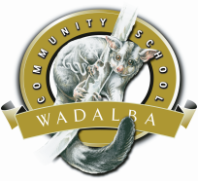
CLASS INFORMATION
K-2W
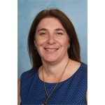
Ms Taryan Walsh
Welcome to 2017! I trust your holiday was as relaxing and rewarding as mine was.

My name is Ms Taryan Walsh and I am looking forward to working with you as your child’s classroom teacher. I have been at Wadalba Community School since 2010. Prior to teaching here, I taught in the Hunter and Central Coast areas. I am a mother of two boys and a girl. When I am not at school, I enjoy netball, reading and going to the beach.

As is the practice in Primary schools, your child will have the following teachers in support roles during the week:
● Library & RFF- Ms Young
● Learning Support- Ms Pattison

Please see the map below to see where our classroom is.
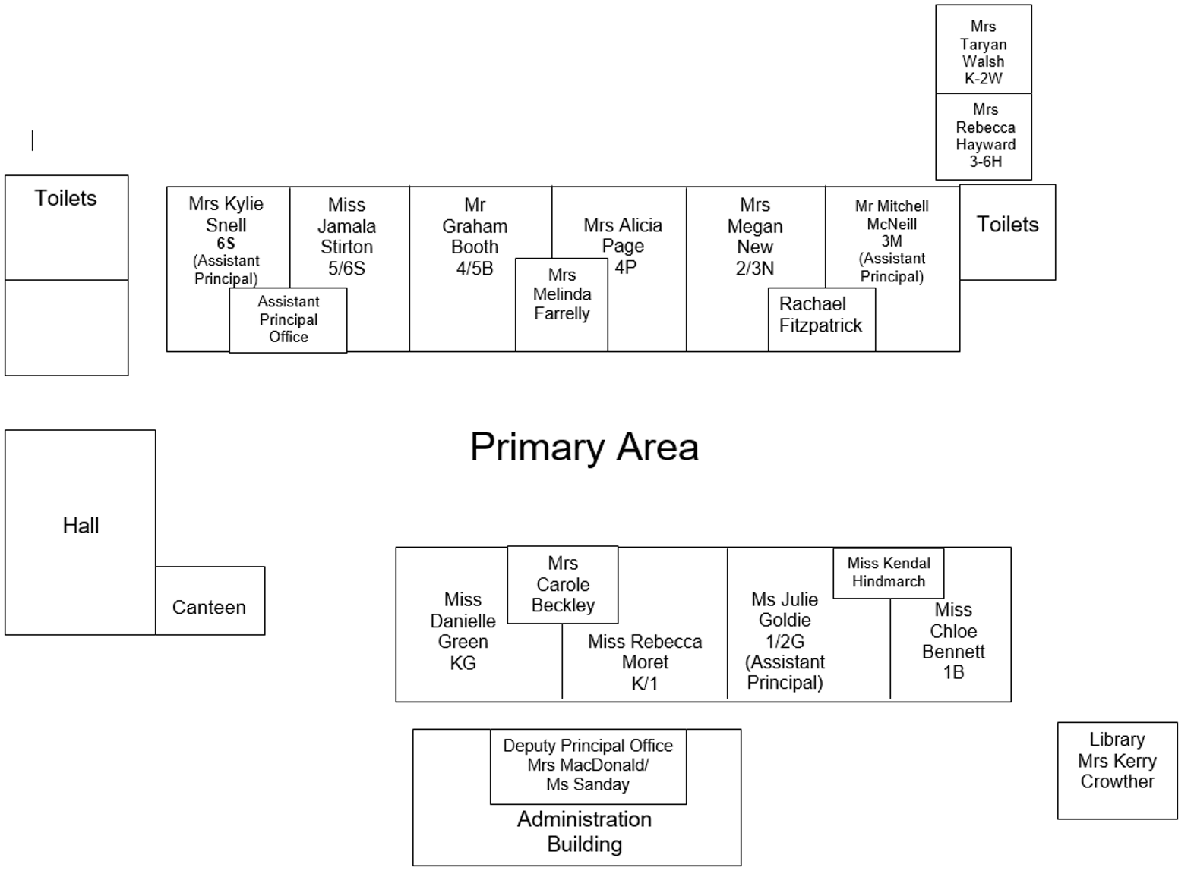

Weekly Overview

MONDAY | TUESDAY | WEDNESDAY | THURSDAY | FRIDAY
● In class Assembly 1:30pm  - Library |  | ● RFF Ms Young  ● School banking day |  | ● Sport Day  ● Return sight words/ Homework

Interviews/ Meetings

You are invited to our first Parent/Teacher Interviews on:
Tuesday 1st March
Bookings for timeslots will be through an online booking system. I hope you can attend. More details will be distributed closer to the evening.

● Outside of set parent interview nights, if you ever wish to request a meeting, these are best arranged at mutually convenient times and when I am class free.
● Casual interviews with me are respectfully discouraged while I have class responsibilities please.

Home Readers
● Your child is to bring their home reader in an A4 pencil case or folder in order to change it for a new book weekly.
● Please listen to your child read each night and record the details on the home reading card.
● The books should be easy when reading at home. They read more difficult texts at school.
● Students receive awards for each 25 nights home reading they complete.

Homework
Homework is to be returned each Friday and is differentiated for individual students. It may consist of home reading, spelling activities, sight words and optional online learning activities.

Class Requisites
The following school requisites can be purchased ready for your child

Box of tissues
Paint Shirt
Library Bag
Home reading folder- waterproof (large A4 pencil case or plastic A4 wallet.
Plastic document wallet

Notes and money
● Please place money in a sealed envelope with your child’s name, class, what it is for and the total enclosed written on the front.
● Excursion money needs to be sent to school at least one week before the date of the excursion or your child will not be able to go.
● Notes being sent home will go into their home reader folders to try to make sure they arrive home to you safely.
● An explanation of an absence must be received within 7 days of your child’s return otherwise it is recorded as an unexplained absence. Partial absences must also have an explanation. Please ensure if your child is late to school that you send back the docket received from the front office explaining the absence.
● Please send a note to school with your child when they return after an absence stating the dates and reason for which they were away. You can also call the school or explain the absence using our school app.

Illnesses
● Please contact the school if your child has a highly contagious infection such as chicken pox, measles, whooping cough, swine flu or any other contagious illness.

Birthdays
● You may send birthday cakes to school but please ensure they are cupcakes or lolly bags. This is due to possible hygiene concerns and the class time that can be interrupted.

Spare Clothes (K-2 only)
● Please send a spare pair of undies/ shorts to school with your child just in case. Accidents do sometimes happen.

Food Breaks
● We have fruit & vegetable break at around 9:30 each morning. Please send a piece of fruit or a chopped vegetable to eat at this time. During this time we take a break and read a story together. We have found this has had a very positive impact on student learning.
● At Wadalba we support healthy eating at school. Please ensure your child has food for recess and lunch each day.

Canteen
● Lunch orders can be placed in the lunch basket (in the classroom) each day Mon- Fri. You may also like to setup an account and order via the internet at www.flexischools.com.au . Our primary canteen is open at lunchtimes and some recess breaks.

News
● Your child will be allocated a news day.
● They may bring in items from home however these are their responsibility to care for. We request all children place toys in the storeroom during class time but cannot guarantee they will not be damaged with your child during breaks. Please ensure that your child does not bring any items that would cause concern if this was to happen.

Uniform
● Please ensure all school clothing is clearly labelled with your child’s name. Black shoes must be worn unless there are special circumstances (a note must be provided). Sport shoes can be worn on Sport Days. Hats MUST be worn by all students as part of our Sun Safety Policy.
● Uniforms can also be ordered online at www.flexischools.com.au .

Drop Off/ Pick Up
● Thank you to all parents/ caregivers for remaining under/near COLA in afternoons. As you can understand this is a busy time when students and teachers are packing up, handing out notes and giving information for the following day. When children see and hear family and friends outside they are often distracted which makes this a much longer process.

Assembly
● Primary assembly is held every Monday starting at 1:30pm. Each class will run an assembly during the term. Please see the newsletter for when our class will be running the assembly. Families are most welcome to attend each week whether or not it is our class on stage.

Sport- Term One
● Sport will be on Friday each week.

Labels
● Please ensure that all of your children’s belongings are clearly labelled. Though we do our best to prevent it, no responsibility will be taken by the school for lost items. All items found without labels can be claimed from lost property.

Our School Website
● Please visit the primary section of our school site for lots of useful information on our school, our events and your child’s education and wellbeing. Many of your questions can often be answered by visiting our website.
http://www.wadalba-c.schools.nsw.edu.au/

Facebook
● Like the Wadalba Facebook page for updates throughout the day, reminders or events and important school information.
● Even if you are not a member of Facebook you can still visit the page at:
https://www.facebook.com/WadalbaCommunitySchool/

Commendation Awards
● Students can receive commendations for a variety of things. Please make sure you keep your child’s commendations and community spirit awards and give them to the DP when they have 5 so they can get a bronze award at assembly.

- 5 Commendations / Community Spirit Awards = Bronze Award
- 3 Bronze Awards = Silver Award
- 3 Silver Awards + Participation in extracurricular school activities + Participation in a community event Gold Award

Banking
● Student banking takes place on Wednesday.
● Bankbooks are collected in the mornings and processed by the banking ladies and returned when completed.

Library
● All students are able to borrow from the library (as long as they have a library bag).
● Classes have a library lesson once a week and students have access to the library most recesses and at lunchtimes. Students also have access to the library computers during these times.
● Our library day is Tuesday

School Office
● The school’s office is located in the administration block and is open from 7.45am to 3.00pm.
● The office is available to students before school, at recess and at lunch.

If you ever have any concerns about your child please feel free to contact me. You can call the office to make an appointment or message me via Class Dojo to request a meeting or phone appointment. The education and wellbeing of your child is very important to me and we all play a part in helping them grow and learn.

Ms Taryan Walsh
Classroom Teacher

