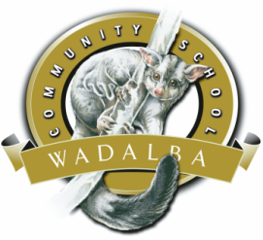
Wadalba Community School
Uniform & Stationery Price List 2018

Unisex Polo Shirts Kindy to Yr 12
Sizes 4 to 3XL $32.00

Surf Hats Kindy to Yr 6
Sizes 55, 57, 59 $15.00

Caps Kindy to Yr 12 $15.00

Jnr Boys Shirts Yr 6 to Yr 9
Sizes 6 to 30 $28.00

Jnr Girls Blouses Yr 6 to Yr 9
Sizes 4 to 30 $35.00

Jnr Girls Skirts Yr 6 to Yr 9
Sizes 8 to 30 $47.00

Primary Tunics Kindy to Yr 6
Sizes 4 to 16 $46.00

WCS Hooded Zip Jacket Kindy to Yr 12
Sizes 4 to 3XL $36.00

WCS Microfibre Jacket Kindy to Yr 12
Sizes 4 to 3XL $50.00

WCS Microfibre Long Pants Kindy to Yr 12
Sizes 4 to 26 $36.00

128p Binder Book $2.00
Music Book $2.50
Maths Book $2.50
A4 Visual Arts Diary $5.00
A3 Visual Arts Diary $8.00

WCS Microfibre Long Pants Kindy to Yr 12
Sizes 4 to 26 $36.00

Sports Polo Kindy to Yr 12
Sizes 4 to 3XL $26.00

WCS Blue Shorts Kindy to Yr 10
Sizes 4 to 3XL $20.00

WCS Black Shorts Yr 10 to Yr 12
Sizes S to 3XL $20.00

Snr Boys Shirts Yr 10 to Yr 12
Sizes 10 to 30 $28.00

Snr Girls Blouses Yr 10 to Yr 12
Sizes 8 to 30 $35.00

Snr Girls Skirts Yr 10 to Yr 12
Sizes 8 to 30 $50.00

Football Socks School Rep Teams
Sizes S to XL $12.00

WCS Fleece Sloppy Joe
Size 4 to 3XL $30.00

Year 7 & 8 Book Packs $52.00
Dictionary $12.00
Calculators $35.00
Diary $ 3.00
Pens, Rulers $ 0.50

Uniform Shop is open for parents from 8:15am to 9:30am Mon to Thur, CLOSED FRIDAYS.
Students are able to purchase uniforms 10mins before the end of recess and lunch
For any enquires contact the school on 4356 2888.

Wadalba Community School
Uniforms and Stationery Online Ordering System

Primary School orders placed will be delivered to your child’s classroom
High School orders must be picked up from the High School Canteen

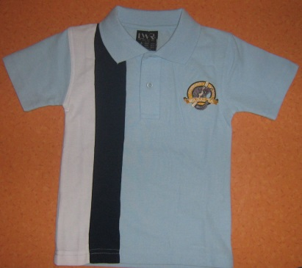
- Order quickly from home or work
- No searching for cash required
pre-paid online!
- Faster and more accurate
- Order at a time convenient to you
We are now using a great new online ordering system called FlexiSchools
How Does it Work?
- Go to www.flexischools.com.au
- Click “Register Now” and enter your email address
- Complete the online registration and add funds to your account via credit card
- Log in at any time and place your orders
- For Primary orders, we will deliver to your child’s classroom, all High School orders will need to be picked up from the High School Canteen.
As purchases are made, the funds are taken from your pre-paid account. The account can be
topped up again in the same way, or set to automatically top-up when it falls below a pre-set
minimum. Each order is sent automatically to the canteen, where an easy-to-read label is
produced with the child’s name, class and order details. This ensures each order is prepared
and delivered accurately to your child.

What Does it Cost?
The online menu is the same price.
However, there is a 29c fee for the online orders to help pay for the labels and the website system.
More Info? If you get stuck or have any questions, just call FlexiSchools on 1300 361 769

